PRODUCT DESCRIPTION
OIL UK GEARLUBE HD 80W-90 is a high quality extreme pressure lubricant for highly loaded gearboxes and final drives. This product can be used wherever the API GL-5 specification is required. It is manufactured from high quality base oils and high levels of extreme pressure additives to provide a lubricant with outstanding anti wear protection. It is designed to cope with the increasing demands of today’s motoring conditions which include high shock load, high torque and high speed service conditions.
APPLICATIONS
OIL UK GEARLUBE HD 80W-90 is suitable for manual gearboxes, including synchromesh, fitted to automotive vehicles, industrial and commercial vehicles.

FEATURES AND BENEFITS
- Excellent oxidation stability
- Outstanding low and high temperature performance
- Suitable for synchromesh gearboxes
- Long service life
- Good protection against rust and corrosion
- High level of wear protection
- Covers API GL-5 and GL-4 offering rationalisation of grades
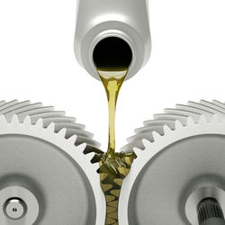

PERFORMANCE LEVEL SPECIFICATIONS

API: GL-5
US Military: Mil-L-2105D

TYPICAL PHYSICAL DATA

Test | Units |  | Typical Properties
Appearance |  |  | Dark Amber
Specific Gravity @ 15.5°C |  |  | 0.890
Kinematic Viscosity @ 100°C | cSt |  | 16.91
Kinematic Viscosity @ 40°C | cSt |  | 168.00
Viscosity Index |  |  | 107
Flash Point (Open) | °C |  | 220
Pour Point | °C |  | -28

